|  |  |  |  |  |  |  |  |  |
| --- | --- | --- | --- | --- | --- | --- | --- | --- |
|  | | | | | | | | |
|  | | FINAL PROJECT INTERIM REPORT | | | | |  | |
|  |  | | | | | | |  |
|  | | | | Decorative |  | | | |
|  | | | | Alif Sathar |  | | | |
|  | | | | November 06, 2025—Developing Privacy-Preserving Artificial Intelligence-based Solutions for Healthcare or IoT—Professor Raj Shukla — BSc Artificial Intelligence |  | | | |
|  | | |  | | |  | | |

|  |  |  |  |  |  |  |  |  |
| --- | --- | --- | --- | --- | --- | --- | --- | --- |
|  |  | | |  |  | | |  |
|  | PROJECT PROPOSAL | | | | | | |  |
|  |  | | |  |  | | |  |
|  |  | |  | | |  | |  |
|  |  |  | The project focuses on developing a privacy-preserving Artificial Intelligence (AI) solution that can be applied to sensitive areas like healthcare or the Internet of Things (IoT). These are fields that use a lot of private and sensitive data, so it’s important to make sure that information stays secure while still training AI models effectively.  To achieve this, I plan to investigate and implement privacy-preserving techniques such as **federated learning** and **differential privacy, Split Learning and Split-Fed Learning** to see how they can help protect data. I’ll focus on using something like **Split-Fed Learning for Healthcare Assets**, where data doesn’t have to be shared directly between devices.  I plan to use **Python and TensorFlow** to build a small prototype model, test it on a suitable dataset, and check how well it performs when privacy-preserving methods are added. The main goal is to show that it’s possible to train AI models that give good results without exposing sensitive data. | | |  |  |  |

|  |  |  |  |  |  |  |  |  |
| --- | --- | --- | --- | --- | --- | --- | --- | --- |
| Decorative | |  |  | | |  |  | |
|  | | THE PROCESS | | | | |  | |
|  | |  |  | | |  |  | |
|  | HEADING FIVE  | **Phase** | **Task** | **Timeline** | **Deliverable** | | --- | --- | --- | --- | | **Week 1–3** | Conduct background research and literature review on privacy-preserving AI techniques like federated, Split and Split-Fed Learning. | Oct–Nov 2025 | Short summary of findings and references | | **Week 4–6** | Finalize project title, objectives, and confirm dataset (either healthcare or IoT data) | Nov–Dec 2025 | Defined project scope and selected dataset | | **Week 7–9** | System design and setup – plan architecture, tools, and frameworks (Python, TensorFlow) | Dec 2025 – Jan 2026 | Basic design diagram and development setup | | **Week 10–13** | Start model development – implement baseline AI model without privacy mechanisms | Jan–Feb 2026 | Early working version of model | | **Week 14–17** | Add privacy-preserving techniques (e.g., federated learning, differential privacy) and test performance | Feb–Mar 2026 | Updated model with privacy layer and initial results | | **Week 18–20** | Evaluation and testing – compare accuracy, efficiency, and privacy trade-offs | Mar–Apr 2026 | Evaluation report and test results | | **Week 21–22** | Final improvements, documentation, and prepare poster presentation | April 2026 | Final submission (Report & Poster) by **24 April 2026** | | | | | | | |  |
|  | Key Deadline Submissions:  * Poster Presentation: Early April * Final Report: 24th April 2026 | | |  |  | | |  |

# ETHICS CONFIRMATION

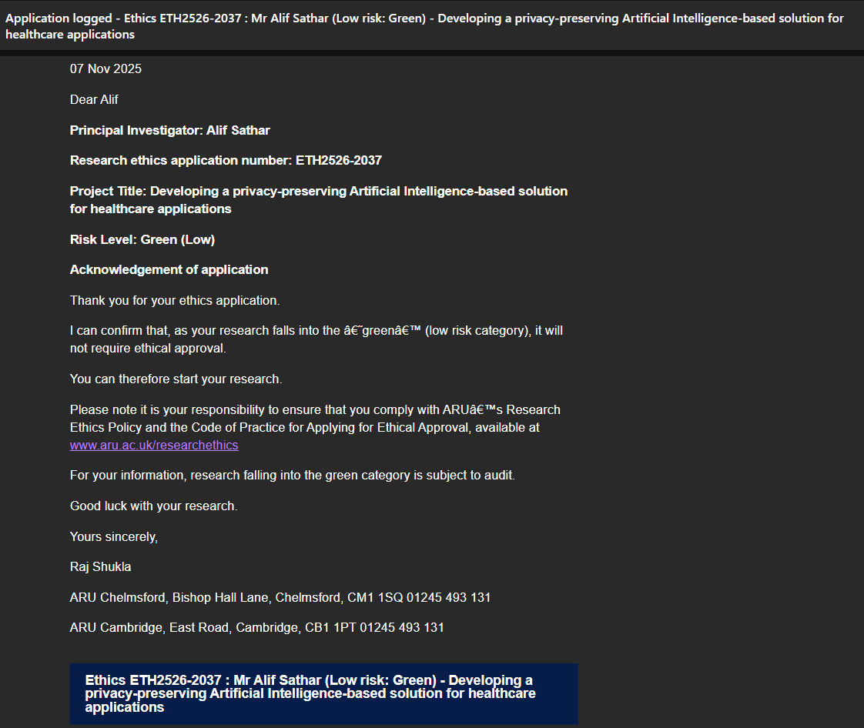

# MY CV



After finishing my degree in Artificial Intelligence at Anglia Ruskin University, I want to build a career where I can apply what I’ve learned to solve real problems using AI. I’m especially interested in roles like **Machine Learning Engineer** or **AI Developer**, where I can work on projects involving automation, computer vision, or generative models.

I hope to start my career in a tech-driven company that values innovation and gives me space to keep learning — companies like **NVIDIA**, **OpenAI**, or **Google DeepMind** inspire me because of their work in shaping the future of AI.

In the long run, I plan to continue my education with a **Master’s degree** in AI or Data Science. My aim is to keep growing as an engineer and researcher, focusing on developing AI systems that are not just powerful but also ethical and beneficial to people.

# EMPLOYABILITY ACTIVITIES

* A screen grab confirming I have attended at least one Employability Event, at the Week 5 Careers Fair.

